1.Explain Need for Data Warehousing
Ans. Data Ware House is a place where large amount of data could be stored.
The need of data warehouse is to generate reports, machine learning ,feed data
to business intelligence. It helps the organizations to access large amount of data.
- Need of Data Warehouse:
- A Common Place to Store Data:
An organization may have data in many different systems and formats.
A data warehouse collects all this data and stores it in one single location, making it easier to access and manage.

- Historical Data:
In traditional databases, only current data is stored.
A data warehouse keeps data from past years, which helps to analyze trends, compare performance, and plan for the future.

- Base for Business Intelligence:
A data warehouse acts as the foundation for tools like Power BI or Tableau that help in data visualization, reporting, and analysis.
It helps management to gain insights and make smart business decisions.

- Time Management:
Since all data is stored in one place, it saves time and effort needed to collect data from multiple sources.
Reports and analyses can be generated much faster.

- Improved Decision Making:
The data warehouse provides accurate, complete, and consistent information.
This helps managers make better, data-driven decisions instead of depending on guesswork.

Explain and DrawData Warehouse Architecture
Data Warehouse Architecture
A Data Warehouse is a system that combine data from multiple sources, organizes it under a single architecture, and helps organizations make better decisions. It simplifies data handling, storage, and reporting, making analysis more efficient. Data Warehouse Architecture uses a structured framework to manage and store data effectively.
There are two common approaches to constructing a data warehouse:
- Top-Down Approach: This method starts with designing the overall data warehouse architecture first and then creating individual data marts.
- Bottom-Up Approach: In this method, data marts are built first to meet specific business needs, and later integrated into a central data warehouse.
Before diving deep into these approaches, we will first discuss the components of data warehouse architecture.
Components of Data Warehouse Architecture
A data warehouse architecture consists of several key components that work together to store, manage, and analyze data.
External Sources: Where data originates. Includes:
- Structured (databases, spreadsheets)
- Semi-structured (XML, JSON)
- Unstructured (emails, images)
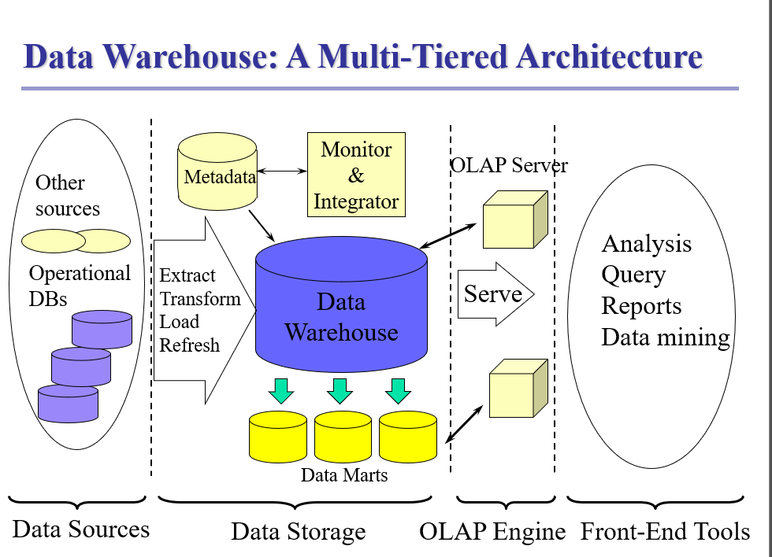
- Query successful
The data warehouse architecture is typically described as a multi-tiered structure. This architecture involves different components and layers working together to extract, transform, store, and provide access to data for analytical purposes.
Data Warehouse: A Multi-Tiered Architecture
The architecture can be conceptualized into three main components: Data Sources, the Data Storage layer (the warehouse itself), and the Front-End Tools layer.
1. Data Sources (Bottom Tier)
This layer consists of the various places where the raw data originates.
- Operational Databases: These are databases used for daily operations and transaction processing (OLTP).
- Other Sources: These include relational databases, flat files, on-line transaction records, and external sources.
2. Data Storage and Processing (Middle Tier)
This is the core of the data warehouse system, responsible for preparing and storing the analytical data.
- ETL (Extract, Transform, Load) and Refresh Layer: This component manages the flow of data from the source systems to the warehouse.
  - Extraction: Getting data from multiple, heterogeneous, and external sources.
  - Cleaning: Detecting errors in the data and rectifying them when possible. Data cleaning and integration techniques are applied to ensure consistency (e.g., naming conventions, encoding, attribute measures).
  - Transformation: Converting data from legacy/host format to the warehouse format.
  - Load/Refresh: Sorting, summarizing, consolidating, computing views, checking integrity, building indices and partitions, and propagating updates from data sources to the warehouse.
- Data Storage: The main data repository, which is physically separate from the operational environment. This is where the core data is stored.
- Data Marts: A subset of the corporate-wide data that is of value to a specific group of users, such as marketing. They can be independent or dependent (derived directly from the main warehouse).
- Metadata Repository: This stores the "data about data," defining warehouse objects. It includes the schema, view, dimensions, hierarchies, data lineage, and information related to system performance.
- OLAP Server: This engine is central to the middle tier, supporting the multidimensional analysis of data. OLAP servers can be implemented as:
  - ROLAP (Relational OLAP): Uses relational or extended-relational DBMS to store and manage warehouse data.
  - MOLAP (Multidimensional OLAP): Uses a sparse array-based multidimensional storage engine.
  - HOLAP (Hybrid OLAP): Combines ROLAP and MOLAP.
3. Front-End Tools (Top Tier)
This tier is used by decision-makers and analysts to interact with the data in the warehouse.
- Query and Reporting Tools: Used for basic querying and generating reports, charts, and graphs.
- Analysis Tools (OLAP): Support multidimensional analysis of data, enabling operations like slice, dice, drill, and pivot.
- Data Mining Tools: Used for knowledge discovery from hidden patterns, supporting tasks like association, classification, and prediction.

Q7.Compare Data Warehouse and Data Marts

Data Warehouse | Data Mart
Data Oriented | Project Oriented
Large in Size | Smaller in Size
Difficult in implementation | Easy to implement
Data Is collected from multiple source | Data is directly collected from Data warehouses
Centralized System | Decentralized System
Denormalized in nature | Normalized
Used for enterprise-wide strategic analysis and decision-making. | Used for department-level tactical decisions.

Q17) Explain MOLAP, ROLAP, DOLAP and HOLAP (5 Marks)
Different OLAP technologies are designed based on data storage and query performance needs.

1. MOLAP (Multidimensional OLAP):
- Stores data in multidimensional cubes instead of relational tables.
- Pre-calculates and stores aggregates for fast performance.
- Example: Cognos, Essbase.
Advantages:
- Very fast query performance.
- Supports complex calculations.
Disadvantages:
- High storage requirements.
- Difficult to scale for very large data.

2. ROLAP (Relational OLAP):
- Stores data in relational databases and performs OLAP operations using SQL queries.
- Example: MicroStrategy, Oracle OLAP.
Advantages:
- Can handle large volumes of data.
- Utilizes existing relational databases.
Disadvantages:
- Slower performance compared to MOLAP.
- More complex query generation.

3. DOLAP (Desktop OLAP):
- A lightweight OLAP model installed on a user’s computer.
- Data is downloaded from the main warehouse for local analysis.
Advantages:
- Fast for individual users.
- Easy to use and low-cost.
Disadvantages:
- Limited data size.
- Not suitable for enterprise-scale analysis.

4. HOLAP (Hybrid OLAP):
- Combines MOLAP and ROLAP.
- Summary data stored in cubes, detailed data in relational databases.
Advantages:
- Balances speed (MOLAP) and scalability (ROLAP).
- Flexible and efficient.
Disadvantages:
- More complex design and maintenance.

✅ Summary:
- MOLAP – Fastest but storage-heavy.
- ROLAP – Scalable but slower.
- DOLAP – Personal use.
- HOLAP – Hybrid of both MOLAP and ROLAP.
Write a note on The Star Schema?
Star Schema is a type of data modelling technique in Data warehousing which is used to represent data in structured and an intuitive way. It consists of central fact table which has measures and dimension table which describe the attributes of measures
- Fact Table:
  - Placed at the center of the star.
  - Contains quantitative or measurable data (called facts) such as sales amount, quantity sold, or profit.
  - Also includes foreign keys linking to dimension tables.
  - Example columns: Product_ID, Customer_ID, Date_ID, Sales_Amount.
- Dimension Tables:
  - Surround the fact table like points of a star.
  - Contain descriptive or textual information that provides context for facts.
  - Example dimensions: Customer, Product, Time, Region.

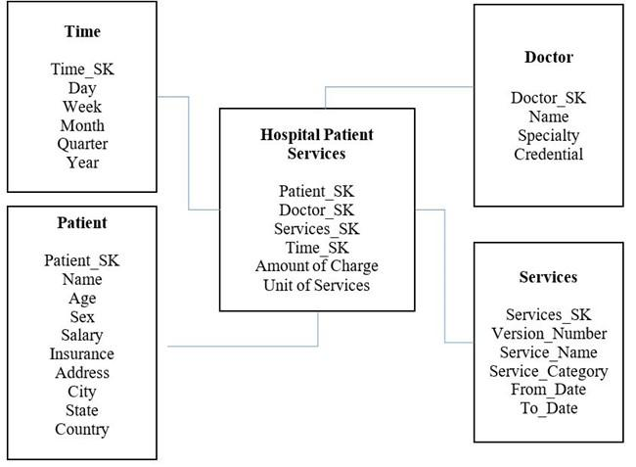

- Each dimension table is joined to the fact table through a foreign key relationship. This allows users to query the data in the fact table using attributes from the dimension tables. For example, a user might want to see sales revenue by product category, or by region and time period.

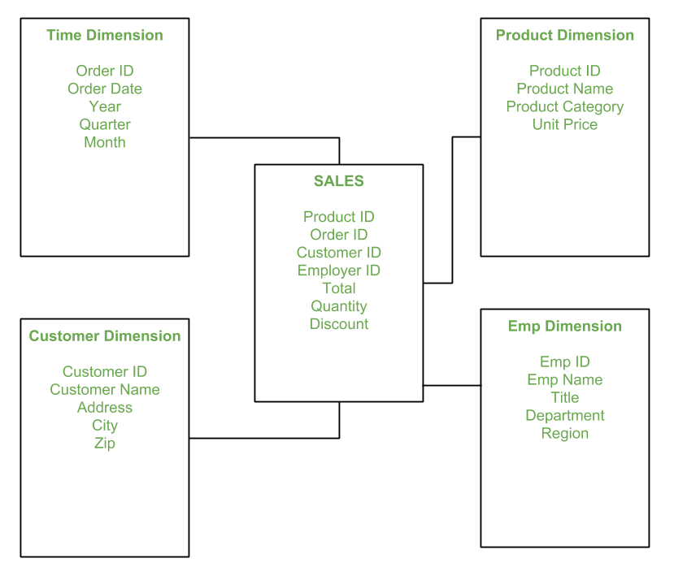

Snowflake Schema
A snowflake schema is a type of multidimensional data model where dimension tables are normalized into multiple related tables, creating a shape that resembles a snowflake when viewed in an entity-relationship diagram. It is an extension of the star schema, consisting of a central fact table connected to normalized dimension tables which, in turn, are linked to further sub-dimension tables. This structure increases data integrity and reduces redundancy but requires more complex queries due to the additional joins needed.
How it works
- Fact table:
The center of the schema contains the fact table, which holds the numeric data for analysis.
- Dimension tables:
The fact table connects to dimension tables, which provide context for the data (e.g., time, location, product).
- Normalized dimensions:
Unlike a star schema, a snowflake schema breaks down the dimension tables into smaller, related tables. For example, a Product dimension might be broken down into Product, Subcategory, and Category tables.
- Hierarchical structure:
Each level of a dimension hierarchy is stored in a separate table, creating a branching structure that gives the model its snowflake appearance.
Pros and cons
- Advantages:
  - Reduced data redundancy: Normalizing dimension tables eliminates data duplication.
  - Improved data integrity: Reduced redundancy leads to more consistent and accurate data

Q.Fact Table and Dimension Table
Fact Tables and Dimension Tables
In a data warehouse, data is organized mainly into two types of tables — Fact Tables and Dimension Tables.
They work together to support data analysis and decision-making.

🧮 1. Fact Tables
Definition:
A Fact Table is the central table in a star or snowflake schema that stores quantitative, measurable data (called facts) about a business process.
Features:
- Contains numeric values that can be analyzed or aggregated (e.g., sum, average, count).
- Includes foreign keys that link to dimension tables.
- Usually very large because it stores transactional or summarized data.
Example:
In a Sales Data Warehouse, the Sales_Fact table might include:
Date_ID | Product_ID | Customer_ID | Sales_Amount | Quantity_Sold
Here:
- Sales_Amount and Quantity_Sold are facts.
- Date_ID, Product_ID, Customer_ID are foreign keys referring to dimensions.
Types of Fact Tables:
- Transaction Fact Table – records individual transactions (e.g., each sale).
- Periodic Snapshot Fact Table – captures data at regular intervals (e.g., monthly sales).
- Accumulating Snapshot Fact Table – tracks progress of a process (e.g., order delivery).

🧭 2. Dimension Tables
Definition:
A Dimension Table stores descriptive attributes related to facts.
It provides context for the numbers in the fact table — answering who, what, when, where, and how about the facts.
Features:
- Usually contains textual or categorical data.
- Has a primary key that links to the fact table’s foreign key.
- Smaller in size compared to fact tables.
Example:
For the Sales Data Warehouse, you might have:
Customer_Dim:
Customer_ID | Customer_Name | City | Region | Age_Group
Product_Dim:
Product_ID | Product_Name | Category | Brand

⚙️ Relationship between Fact and Dimension Tables:
- The Fact Table sits at the center.
- It connects to multiple Dimension Tables via keys.
- Together, they form a Star Schema (or Snowflake Schema).

⭐ In short:
Aspect | Fact Table | Dimension Table
Purpose | Stores measurable data (facts) | Stores descriptive data (context)
Data Type | Numeric | Textual / Categorical
Size | Usually large | Usually smaller
Keys | Foreign keys to dimensions | Primary keys linked from facts
Example | Sales_Fact | Customer_Dim, Product_Dim, Time_Dim

💬 Example in One Line:
In a Sales Warehouse, the Fact Table shows “how much was sold,” while the Dimension Tables explain “who bought it, what product, where, and when.”

18)Define Challenges in ETL Functions
Scalability:
As the organization grow the amount of data also increases. Old systems struggle to handle such large amount of data.
The company may need to handle millions of data
Example: An organization which previously handles 100 stores may need to handle 1000 stores
Data Integration:
Data from Different sources are collected, then cleaned and then loaded into the database, they may be different formats .Combining the data from various sources makes it complex
Example: ales data from an online store (in JSON format) and data from an ERP system (in SQL tables) must be combined correctly.Ignoring end users requirement
Data Quality Problems:
Data collected from multiple sources often has missing values, spelling mistakes, or duplicates.
If data quality is poor, business reports and decisions will be inaccurate.
✅ Example: A customer’s name stored as “A. Singh” in one system and “Anita Singh” in another can lead to duplicate records.
9️⃣ Tightly Coupled Pipeline Components
When ETL stages (Extract → Transform → Load) are too dependent on each other, a change in one part can break the rest.
A flexible, modular design helps avoid this issue.
✅ Example: If the extraction step’s output file name changes, the transform step might fail if it expects the old name.
Security:
ETL moves large amounts of sensitive information, such as customer or financial data.
If not encrypted or properly controlled, this data can be leaked or hacked.
✅ Example: During extraction from a banking database, customer account details must be encrypted to prevent misuse.
Data Transformation Issues:
Transformation involves changing, cleaning, and summarizing data according to business rules.
If not properly designed, transformations can be time-consuming and error-prone.
✅ Example: Converting multiple date formats like “2025-10-14” and “14/10/25” into one common format before loadin

Q26.Illustrate Big data
ANS.
Big Data refers to large amount of information or datasets which cannot be managed by traditional database system.
Types:
- Structured Data:
Organized and stored in tables (e.g., databases).
- Semi-Structured Data:
Partly organized (e.g., XML, JSON).
- Unstructured Data:
No fixed format (e.g., emails, images, videos).

These data are generated continuously from multiple sources
Characteristic:
5 V’s of Big Data
- Volume: Large Amount of data is generated from various sources like social media, sensors, etc. continuously. It may range from terabytes to petabytes
- Variety: The data may be in different formats like: JSON,XML
It may be structured or semi structure or unstructured
- Velocity: These data are generated continuously and are processed in real time or real near time
- Value : Extracting meaningful insights from big data
- Veracity: Data quality may vary complete,inconsistent,incomplete.
How Big Data Works
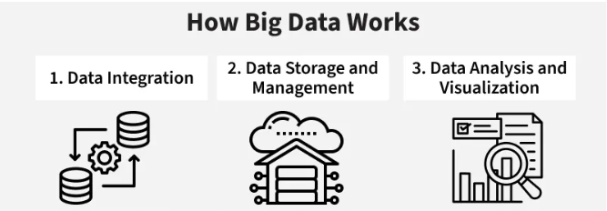

1. Data Integration
- Collect data from multiple sources: apps, sensors, websites, logs, etc.
- Tools used: Apache NiFi, Flume, Sqoop
2. Data Storage and Management
- Store data in data lakes or distributed file systems like HDFS
- Tools used: Hadoop HDFS, Amazon S3, Google Cloud Storage
3. Data Analysis and Visualization
- Run analytics to extract insights using tools like Spark or Python
- Tools used: Apache Spark, Tableau, Power BI, Python (Pandas, NumPy)

27.NoSQL
NoSQL databases are the nonrelational databases which are used to store large amount of structured, semi structured, unstructured data.
1.Unlike Traditional Databases, they use Models like
key-value: A unique key is associated with the value which may be simple or complex,
document: They use document like JSON,XML files,
graphs : Use nodes as entities and edge to represent relationship between them,
etc; which makes them flexible and scalable
2.They are Horizontally scaled ;Thus, in order to handle more load it enables to add more
servers to the system instead of vertical scaling.
3.NoSQL uses Base Consistency Model instead of acid properties
Ba-Basically Available
S-Soft State
E-Eventually Consistent
Examples Include: Mongo DB, Couch DB
4.NoSQL is widely used by real time applications
5.These are Schema less, which allow for dynamic and evolving data models, which is
suited for unstructured and semi-structured data.

29.Explain Cap Theorem
Meaning:
The CAP Theorem (also called Brewer’s Theorem) explains the three main properties that a distributed database system can have:
- C – Consistency
- A – Availability
- P – Partition Tolerance
It states that in any distributed system, it is impossible to achieve all three properties at the same time.
A system can only provide any two of the three.

⚙️ 1. Consistency (C):
- Every node (server) in the system shows the same data at the same time.
- When data is updated in one place, all other nodes reflect that change immediately.
Example: In a banking system, if ₹500 is withdrawn from one branch, every branch shows the same balance right away.

⚙️ 2. Availability (A):
- The system is always available to respond to user requests, even if some servers fail.
- The response might not always have the latest data, but the system doesn’t crash.
Example: Even if one server is down, you can still view your account details from another.

⚙️ 3. Partition Tolerance (P):
Partition tolerance means a distributed system continues to operate even when some nodes cannot communicate due to network failures.
- Data may be split (“partitioned”) across servers, but the system still runs without total failure.
Example: If network connection between two data centers fails, each one can still serve local users.

⚖️ CAP Trade-off:
According to the theorem, a distributed system can only satisfy two of the three properties at a time, not all three.
Combination | What it Means | Example System
CA (Consistency + Availability) | Works well when there are no network failures. All nodes have same data and system is available. | Traditional databases (single server)
CP (Consistency + Partition Tolerance) | System stays consistent even if network fails, but may not respond until problem is fixed. | MongoDB, HBase
AP (Availability + Partition Tolerance) | System stays available even during network issues but may return outdated data. | Cassandra, CouchDB

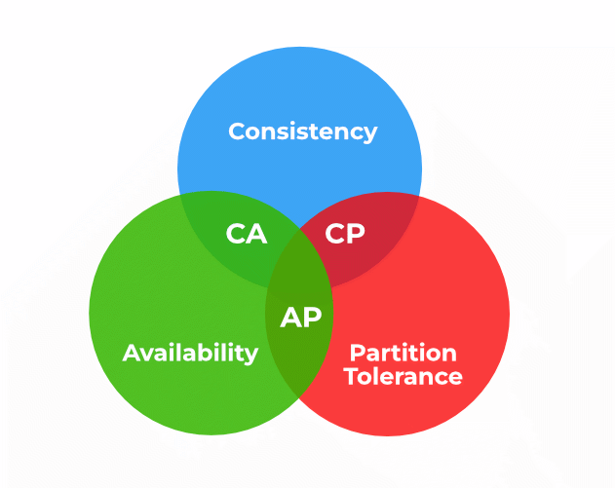
30.Describe BASE property
Ans.
The BASE property is used in NoSQL databases (like MongoDB, Cassandra, etc.) as an alternative to the ACID property used in relational databases.
Basically Available:
- The system always gives a response to every request, even if some part of the system fails.
- The data it shows might not be the latest, but the system remains available to users.
Example: If one server fails, another one still gives the required data so the app doesn’t stop working.

2. Soft State:
- The system’s data may change or update automatically over time, even if no user action happens.
- This means temporary differences can exist between servers until updates are complete.
Example: When you update your profile picture, it may take a few seconds to show on all your devices.

3. Eventually Consistent:
- After some time, all copies of the data across servers will become the same (consistent).
- There’s no fixed time for when this happens, but it will happen eventually.
Example: A new post on social media may take time to appear everywhere, but after a short delay, all users will see the same content.

